## DJI_Crayon_cloud_c.pngDJI_Crayon_star_c1.pngDJI_Crayon_star_c3.png

Panda Class Newsletter



**With Huang Laoshi,**

**Ms. Wendy, and Ms. Lauren**

**Week 41: 5/29/17-6/2/17**



**Weekly News…**

It’s almost the end of the school year!!! We have so many things to celebrate! We made thank you cards and honored our volunteers who have been helped us this year on the Friday school assembly. For the PYP unit, we were still working on Personal Histories unit. We kept tracking Cleveland’s weather on the journals by using simple Chinese sentences. We finished our Early Language Listening and Oral Proficiency Assessment (ELLOPA) test this week, Hooray!!! For kindergarten math we reviewed and practiced number bonds. For 1st grade math, we are still working on numbers to 120. We reinforced classroom routines and school wide expectations and we earned 150+ stickers for the pizza party!!! If you have any questions, please contact us [yuting@gala-prek8.org](mailto:yuting@gala-prek8.org), [wendy@gala-prek8.org](mailto:wendy@gala-prek8.org) or [lauren@gala-prek8.org](mailto:lauren@gala-prek8.org). Thank you so much for your support all the time and enjoy the weekend!

**Thank You!**

**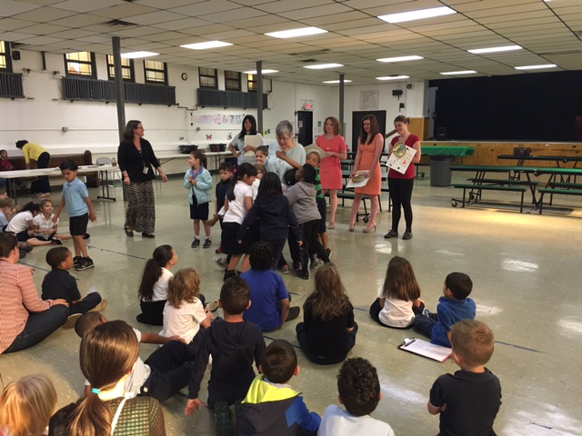**

**Chinese Characters**

几 (how many) 年 (year)

星 期 (week)

**Announcements**

* **June 7 – Field trip to national history museum**
* June 9 - all student **GOLDEN TURTLE AWARD** ceremony & Field day
* Panda Weebly site: <http://galapanda.weebly.com/>
* Panda Quizlet class: <https://quizlet.com/class/4495562/>

Huang Laoshi