## DJI_Crayon_cloud_c.pngDJI_Crayon_star_c1.pngDJI_Crayon_star_c3.png

Panda Class Newsletter



**With Huang Laoshi,**

**Ms. Wendy, and Ms. Lauren**

**Week 40: 5/22/17-5/26/17**



**Weekly News…**

Hello Panda families, do you know this week is our 40th week of school?! It’s hard to believe the school year is almost over. In this week we are still in our last PYP unit, Personal Histories. We started to track Cleveland’s weather and recorded on the journals by using simple Chinese sentences. We started our Early Language Listening and Oral Proficiency Assessment (ELLOPA) test for Mandarin this Friday and they all did amazing!!! We also made a beautiful Memorial Day craft to take home. For kindergarten math we reviewed and practiced number bonds. For 1st grade math, we are still working on numbers to 120. We reinforced classroom routines and school wide expectations and we are still using our sticker chart to earn pizza, we have almost 120 pizza stickers by the end of this week!!! If you have any questions, please contact us [yuting@gala-prek8.org](mailto:yuting@gala-prek8.org), [wendy@gala-prek8.org](mailto:wendy@gala-prek8.org) or [lauren@gala-prek8.org](mailto:lauren@gala-prek8.org). Thank you so much for your support all the time and enjoy the long weekend!

**Art**

Secondhand Mutts rescue visited the students at GALA today! You can find photographs from the visit here.  <http://tinyurl.com/SHMatGALA2017> Students were able to practice the dog safety that they learned when the Cuyahoga County Animal Shelter visited and asked some really great questions about taking care of dogs, adopting and having a career related to animals.

Also, we are holding a **short fundraiser for Secondhand Mutts**. The money we are able to raise will go towards the local Cleveland-based dog rescue Secondhand Mutts. They are a 501c3 non-profit organization that cares for homeless dogs, covers their veterinary costs and helps them find loving families. Secondhand Mutts founder Becca Riker and volunteer Matt came to visit GALA on May 25th and gave a presentation to our students. Right now they are covering vet bills for Luke who is undergoing heartworm treatment (total cost is around $1,000) and Jonny Legs who has a broken leg that started to heal before it was able to be set in a cast. Half sheet fliers went home with your students today. **Starts - Tuesday, May 30    Ends - Monday, June 5** Ms. Jeanette and Ms. Lauren will be collecting donations. More information:  [www.SecondhandMutts.com](http://www.secondhandmutts.com/) other ways to support the rescue:

<http://secondhandmutts.org/volunteer>  <http://secondhandmutts.org/foster-program>

<http://secondhandmutts.org/adoption>

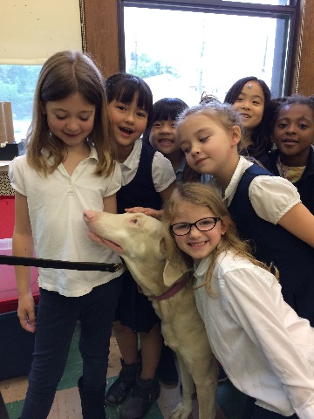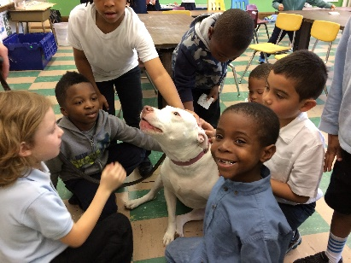

**Announcements**

* **No School on Monday, May 29th - Memorial Day**
* June 2 - **Volunteer/Board Appreciation Day**.
* June 9 - all student **GOLDEN TURTLE AWARD** ceremony

Huang Laoshi