

Panda Class Newsletter



**With Huang Laoshi,**

**Ms. Wendy, and Ms. Lauren**

**Week 39: 5/15/17-5/19/17**



**Weekly News…**

We finished our NWEA-MAP testing this week! Students worked so hard and it’s so amazing to see their growth! All butterflies flew out this week and we miss them . We also finished up collecting all butterfly life cycle pictures and put them into a journal. Starting this week, we moved to our last PYP unit, personal histories. We practiced how to use sentences to express ourselves. We also did a Cleveland weather report on a daily basis. For kindergarten math we practiced numbers to 100 and for 1st grade math, we worked on numbers to 120. We reinforced classroom routines and school wide expectations and we still using our sticker chart to earn pizza, we have almost 100 pizza stickers so far!!! If you have any questions, please contact us [yuting@gala-prek8.org](mailto:yuting@gala-prek8.org), [wendy@gala-prek8.org](mailto:wendy@gala-prek8.org) or [lauren@gala-prek8.org](mailto:lauren@gala-prek8.org). Thank you so much for your support all the time and have a good weekend!

**Announcements**

* **No School on Monday, May 29th**
* June 2 - **Volunteer/Board Appreciation Day**.
* June 9 - all student **GOLDEN TURTLE AWARD** ceremony

**Chinese Characters**

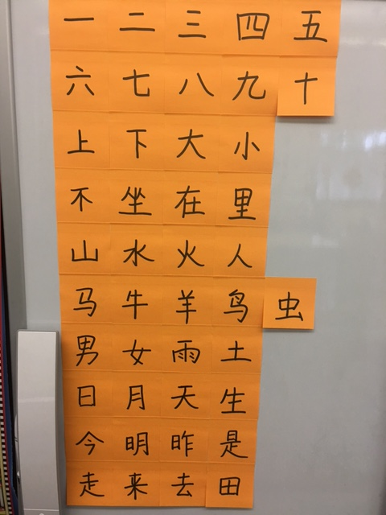

**Art**

I'll upload photos from the dog toy making tomorrow with the same link I sent last week.

The students at GALA have been using their creativity and time in art class to create dog toys for the dogs waiting to be adopted at the Cuyahoga County Animal Shelter. They will be donated this weekend and will bring comfort and happiness to dogs in need! Students learned a three and four strand braid as well as the square knotting technique. If you would like to bring your student to CCAS this weekend with other GALA families Ms. Lauren has scheduled a tour for Saturday at 11a-11:45a and a tour and some activities with the dogs for Sunday from 10:30a-12p. Lauren will be attending on Sunday and the toys will be donated at that time. If you are interested in participating either day, please email Lauren at [Lauren@gala-prek8.org](mailto:Lauren@gala-prek8.org). The shelter is located at 9500 Sweet Valley Dr, Valley View, OH 44125.

Huang Laoshi