

Panda Class Newsletter



**With Huang Laoshi,**

**Ms. Wendy, and Ms. Lauren**

**Week 38: 5/8/17-5/12/17**



**Weekly News…**

This week is our NWEA MAP testing week! Students did a great job taking their time to solve questions and presenting what they have learned so far. AMAZING!!! And we finally have our butterflies coming out!! We completed the butterfly journal, let them go on Friday and said goodbye to our little friends. What’s more, students performed a Chinese song 我的好妈妈 (My Good Mom) on stage during Friday assembly for the mother’s day. We also made a paper flower craft and handed it to beloved mom. For kindergarten/1st Grade math we reviewed how we solve math questions and prepared for the state test. We reinforced classroom routines and school wide expectations and we still using our sticker chart to earn pizza. If you have any questions, please contact us [yuting@gala-prek8.org](mailto:yuting@gala-prek8.org), [wendy@gala-prek8.org](mailto:wendy@gala-prek8.org) or [lauren@gala-prek8.org](mailto:lauren@gala-prek8.org). Thank you so much for your support all the time and have a good weekend!

**Announcements**

* **No school next Monday (5/15) – Teachers PD**
* 我的好妈妈(My good mom): <https://www.youtube.com/watch?v=FabGKmRehqk>

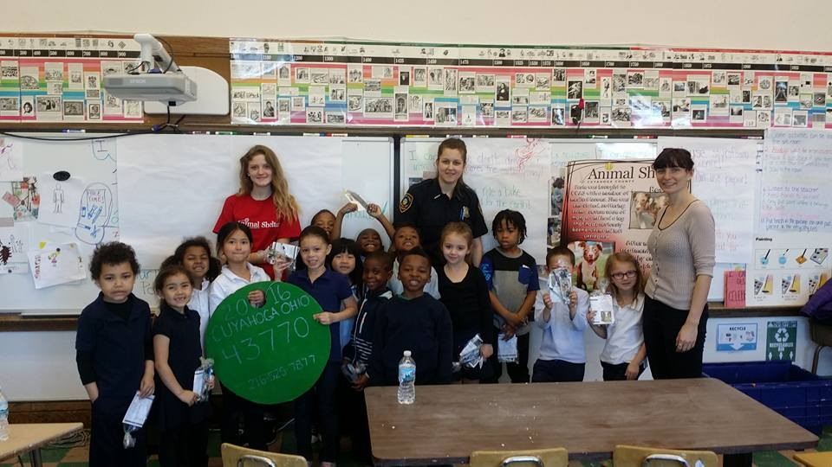

**Art**

The students had guest speakers from the Cuyahoga County Animal Shelter in art and will use the information they learned to create dog toys using braiding and knotting techniques next week. If you have any large pieces or scraps of fleece material at home that you don't have use for, please send it in with your student. We can use it for this art and service project! The toys will be donated to the CCAS the weekend of the 20th and 21st. Please check the family Facebook page and your email from Ms. Lauren for more information about visiting the shelter with your student.

**Chinese Characters**

**田（field）、来（come）**

**去（go）、走（walk）**

Huang Laoshi