

Panda Class Newsletter



**With Huang Laoshi,**

**Ms. Wendy, and Ms. Lauren**

**Week 36: 4/24/17-4/28/17**



**Weekly News…**

This week we kept learning our unit “People, Animals and Plants” and focused on butterfly life cycle. We had six little friends-caterpillars in our room. We are so excited about these cuties! It’s so amazing to see them in a jar. We paid close attention about their changes every day. At the same time we keep drawing our observation journal daily. We kept practicing the Chinese ancient poem 咏鹅 and performed at the school assembly on Friday morning. For Kindergarten math we finished number to 40, practiced tens and ones and moved to fraction. For 1st Grade math we finished multiplication and started fraction as well. We reinforced classroom routines and school wide expectations and we will start running our sticker chart to earn pizza next Monday. If you have any questions, please contact us [yuting@gala-prek8.org](mailto:yuting@gala-prek8.org), [wendy@gala-prek8.org](mailto:wendy@gala-prek8.org) or [lauren@gala-prek8.org](mailto:lauren@gala-prek8.org). Thank you so much for your support all the time and have a good weekend!

**PYP contents**

**People, Animal and Plants:**

**-Animal: Butterfly life cycle**

**- Animal habitat**

**Chinese Characters**

**昨 (昨天 yesterday) 今(今天 today)**

**明 (明天 tomorrow) 是 (is)**

**Announcements**

* Panda class Weebly website: <http://galapanda.weebly.com/>
* Quizlet classroom: <https://quizlet.com/class/4495562/>
* Butterfly life cycle video: <https://www.youtube.com/watch?v=MoLCSzpheBs>
* The very hungry caterpillar Chinese version: <https://www.youtube.com/watch?v=Hri3ELIBjO0>
* Chinese Poem 咏鹅: <https://www.youtube.com/watch?v=i7E4taM7zDg>

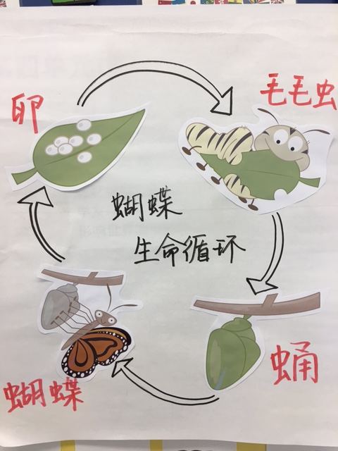

Huang Laoshi