

Panda Class Newsletter



**With Huang Laoshi,**

**Ms. Wendy, and Ms. Lauren**

**Week 35: 4/18/17-4/21/17**



**Weekly News…**

This week we kept learning our unit “People, Animals and Plants” and focused on plants. We reviewed the parts of plants, what plants need to grow, and learned something new about plants life cycle: seed (种子), sprout (发芽), mature plant (成熟) and flower (开花). On Friday we also had fun doing earth day activity: we learned and identified what can be recycled, and what can we do to make our earth healthier. This month is Poetry Month, we watched and learned a Chinese ancient poem 咏鹅. For Kindergarten math we moved to number to 40 and practiced tens and ones. For 1st Grade math we started multiplication with manipulatives. We reinforced classroom routines and school wide expectations. If you have any questions, please contact us [yuting@gala-prek8.org](mailto:yuting@gala-prek8.org), [wendy@gala-prek8.org](mailto:wendy@gala-prek8.org) or [lauren@gala-prek8.org](mailto:lauren@gala-prek8.org). Thank you so much for your support all the time and have a good weekend!

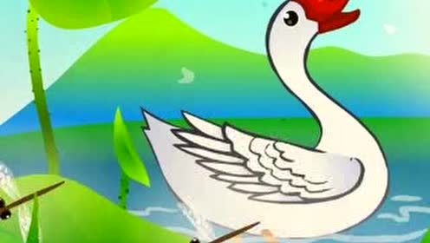

**Chinese Characters**

**是 (is)**

**昨 (昨天 yesterday)**

**PYP contents**

**People, Animal and Plants:**

**-Plants: Plant life cycle**

**Earth Day:**

**-Recycle/Earth day mini-book**

**-Earth day heart**

**Chinese Poem**

**咏鹅**

**骆宾王**

**鹅鹅鹅，**

**曲项向天歌。**

**白毛浮绿水，**

**红掌拨清波。**

**Announcements**

* Panda class Weebly website UPDATED: <http://galapanda.weebly.com/>
* Quizlet classroom: <https://quizlet.com/class/4495562/>
* Chinese Poem: <https://www.youtube.com/watch?v=i7E4taM7zDg>

Huang Laoshi