

Panda Class Newsletter



**With Huang Laoshi,**

**Ms. Wendy, and Ms. Lauren**

**Week 34: 4/10/17-4/13/17**



**Weekly News…**

This week we kept learning our new unit “People, Animals and Plants”. We’ve learned the parts of plants are: 根root、茎stem、叶leaf、花flower、种子seed. We made a flower and identified each parts. Also, we learned about what plants need: sunshine, water, air, and food (soil). We celebrated Easter by making a bunny ear headband and hunting for 3 eggs with Chinese characters/math questions in it. If they can tell Huang Laoshi how to read the characters/solve the math questions, they receive a prize. For Kindergarten math we were still practicing subtraction by using number line. For 1st Grade math we kept learning numbers to 40, and focused on ways of doing addition/subtraction. We reinforced classroom routines and school wide expectations. If you have any questions, please contact us [yuting@gala-prek8.org](mailto:yuting@gala-prek8.org), [wendy@gala-prek8.org](mailto:wendy@gala-prek8.org) or [lauren@gala-prek8.org](mailto:lauren@gala-prek8.org). Thank you so much for your support all the time and have a wonderful break!

Parts of Plant Craft

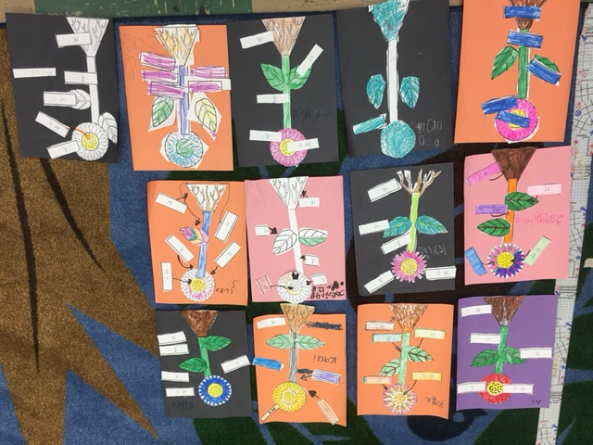

**Chinese Characters**

**今 (今天today)**

**生 (生日 birthday)**

**PYP contents**

**People, Animal and Plants:**

**-Plants: Parts of the plants**

**-What do plants need to grow?**

**Art**

The students have been doing a really wonderful job of drawing animals step by step by identifying basic geometric shapes within the form and then combining and connecting them.

**Announcements**

* No school this Friday (4/14/2017) and the following Monday (4/17/2017)
* Happy Easter! 复活节快乐！
* Panda class Weebly website UPDATED: <http://galapanda.weebly.com/>

Huang Laoshi