

Panda Class Newsletter



**With Huang Laoshi,**

**Ms. Wendy, and Ms. Lauren**

**Week 33: 4/3/17-4/7/17**



**Weekly News…**

Welcome back panda families! Hope you enjoyed your spring break. Panda has a new student-Annaliese Kole coming this week!!! Welcome!!!

This week we started our new unit People, Animal and Plants. We’ve learned how to identify living things and non-living things, and the characteristics of them. We learned that living things need food/water, breathe, grow, reproduce, and move. We had a pre-assessment, did some living/non-living things sorting and guessed how animals move. For Kindergarten math we were still practicing subtraction by using number line. For 1st Grade math we kept learning numbers to 40, and focused on ways of doing addition/subtraction. We reinforced classroom routines and school wide expectations. If you have any questions, please contact us [yuting@gala-prek8.org](mailto:yuting@gala-prek8.org), [wendy@gala-prek8.org](mailto:wendy@gala-prek8.org) or [lauren@gala-prek8.org](mailto:lauren@gala-prek8.org). Thank you so much for your support all the time and have a wonderful weekend!

**We had a guest speaker in Art to share some music!**

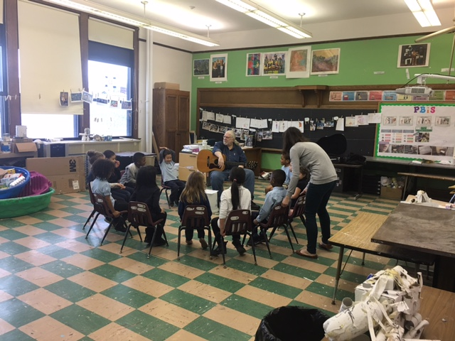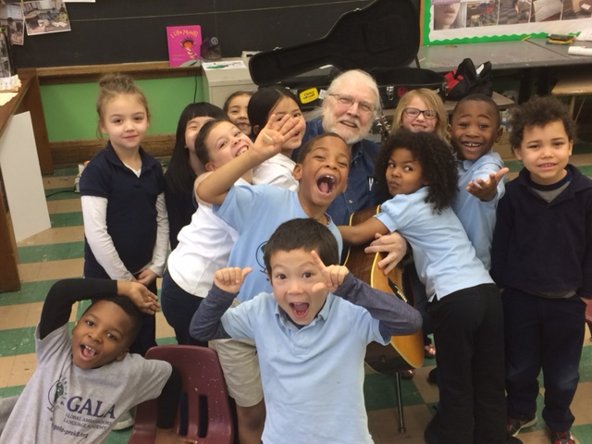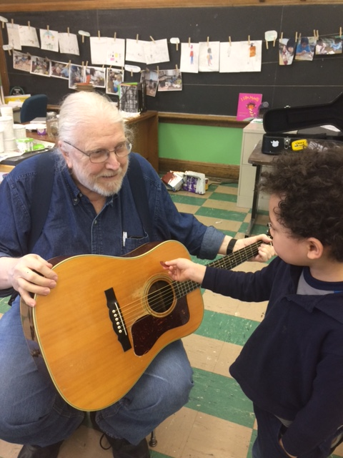

**PYP contents**

**People, Animal and Plants:**

**-Pre-assessment**

**-Living/non-living things sorting**

**-How animal moves**

**Chinese Characters**

**天 (day/sky) 生 (birth/life)**

**Announcements**

* No school next Friday (4/14/2017) and the following Monday (4/17/2017)
* Panda class Weebly website: <http://galapanda.weebly.com/>
* Living/Non-living things Quizlet Flashcards: <https://quizlet.com/_3b8lgu>

Huang Laoshi