

Panda Class Newsletter



**With Huang Laoshi,**

**Ms. Wendy, and Ms. Lauren**

**Week 30: 3/6/17-3/10/17**



**Weekly News…**

This week we focused on preparing and conducting all the science projects for all the groups. Everyone was very dedicated and working hard to get their experiments ready. They asked questions and formed their hypothesis for their experiment. Then we conducted the experiments step by step and recorded the observations. They were all very proud of themselves for what they can do to use experiment to prove or correct their hypothesis. We also learned how to write their own science journal. We will be working on their display board next week and get ready for the Science Fair. Can’t wait to see you and share these fun experiments!! For math, we kept practiced time to half hour and reviewed time in math center activities. We reinforced classroom routines and school wide expectations. If you have any questions, please contact us [yuting@gala-prek8.org](mailto:yuting@gala-prek8.org), [wendy@gala-prek8.org](mailto:wendy@gala-prek8.org) or [lauren@gala-prek8.org](mailto:lauren@gala-prek8.org). Thank you so much for your support and have a wonderful weekend!

**Announcements**

* Science Fair is Wednesday March 15 from 4:30-6:00 at the Gym. You are invited!
* Field Trip to the Great Lakes Science Center is on March 22. Please sign the permission form and return it to school by March 17th.
* Vocabulary about the scientific methods: <https://quizlet.com/_3705is>
* Panda class weebly website! <http://galapanda.weebly.com/>

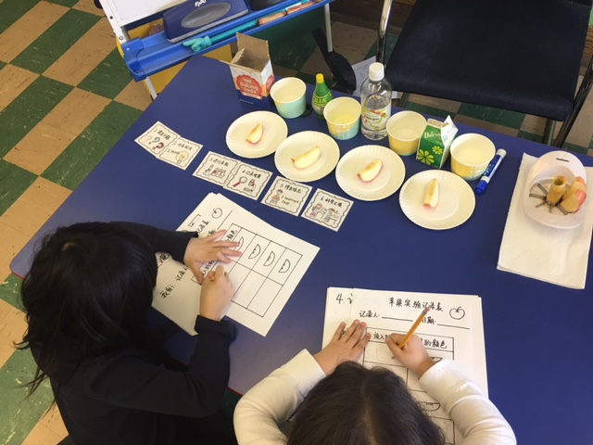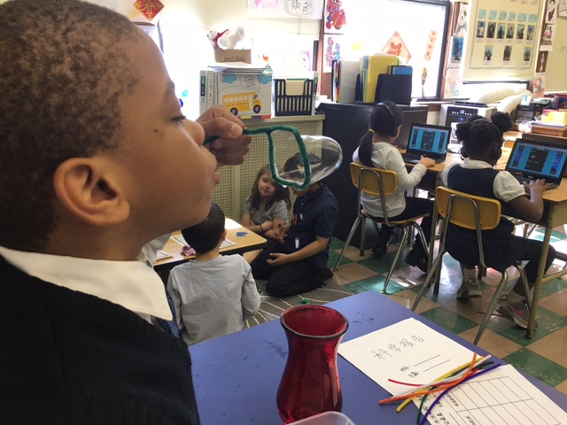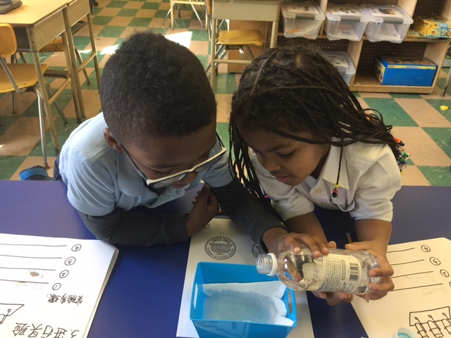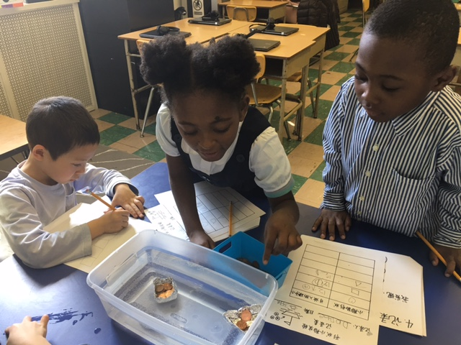

**Chinese words learning**

**科学方法 (Scientific method) 提出问题 (Ask a question)**

**形成假设 (Form a hypothesis) 进行实验 (Do experiments)**

**记录观察 (Record observations) 得出结论 (Draw a conclusion)**

**PYP contents**

* **Science Moves**

**- Science Fair Experiments and journals**

Huang Laoshi