

Panda Class Newsletter



**With Huang Laoshi,**

**Ms. Wendy, and Ms. Lauren**

**Week 29: 2/27/17-3/3/17**



**Weekly News…**

Our “Science Moves” unit is moving along with learning about the scientific methods. We learned that there are five steps: ask a question, form a hypothesis, do experiments, record observations and draw a conclusion. We also did a magnet experiment to test out what objects in class are magnetic. We talked about our science fair which is taking place on March 15th. Everyone is very excited. For math, we started four different math centers this week: computer center, game center, shape center and teacher center. For both kindergarten and first grade we started to learn clock reading. We practiced time to hour and time to half hour in the pass week. We also reinforced classroom routines and school wide expectations. If you have any questions, please contact us [yuting@gala-prek8.org](mailto:yuting@gala-prek8.org), [wendy@gala-prek8.org](mailto:wendy@gala-prek8.org) or [lauren@gala-prek8.org](mailto:lauren@gala-prek8.org). Thank you so much for your support and have a wonderful weekend!

**PYP contents**

* **Science Moves**

**- Scientific methods**

**- Magnet test**

**Announcements**

* *Please keep toys at home.*
* Vocabulary about the scientific methods: <https://quizlet.com/_3705is>
* Vocabulary about properties of matter: <https://quizlet.com/_3706de>
* Panda class weebly website! <http://galapanda.weebly.com/>

**Take a quick look at our door!!!**

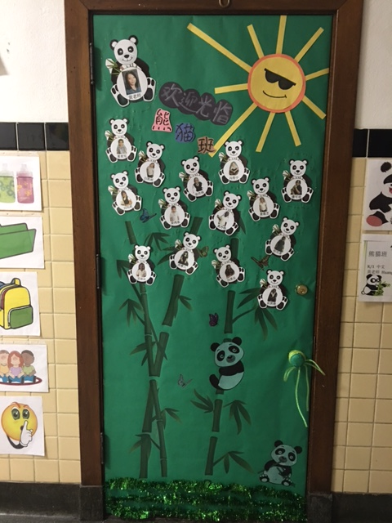

**Chinese words learning**

**科学方法 (Scientific method) 提出问题 (Ask a question)**

**形成假设 (Form a hypothesis) 进行实验 (Do experiments)**

**记录观察 (Record observations) 得出结论 (Draw a conclusion)**

Huang Laoshi