

Panda Class Newsletter



**With Huang Laoshi,**

**Ms. Wendy, and Ms. Lauren**

**Week 28: 2/21/17-2/24/17**



**Weekly News…**

Hi Panda families, I’m so happy to announce that we have a new student coming this week, Alex Noirie! We made welcome cards for Alex and hope she will enjoy to be a part of panda class!

This is the third week of our “Science Moves” unit. We wrapped up properties of matter and practiced how we described items. We will start to get prepared for the science fair next week. For Black History Month we had a chance to invite Ms. Barbara Rogers, our guest speaker, to give us a presentation about African American nurses. For math Kindergarten we kept working on addition. For math 1st grade we started to learn graphs. We also reinforced classroom routines and school wide expectations. If you have any questions, please contact us [yuting@gala-prek8.org](mailto:yuting@gala-prek8.org), [wendy@gala-prek8.org](mailto:wendy@gala-prek8.org) or [lauren@gala-prek8.org](mailto:lauren@gala-prek8.org). Thank you so much for your support and have a wonderful weekend!

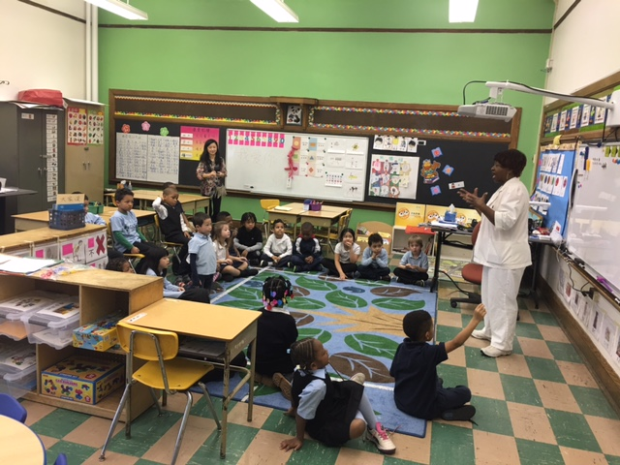

**Announcements**

* We won the competition for Leukemia and Lymphoma Society Campaign! You did an amazing job raising money for kids with cancer! THANK YOU!!!

*1st Place Raised $314.39-PANDA CLASS*

* Panda class weebly website! <http://galapanda.weebly.com/>

**Chinese Characters**

**男 (man) 女 (woman)**

**土 (dirt/soil) 雨 (rain)**

**PYP contents**

* **Science Moves**

**- Properties of Matter**

* **Black History Month**

**- Guest Speaker: Ms. Barbara Rogers**

Huang Laoshi