

Panda Class Newsletter



**With Huang Laoshi,**

**Ms. Wendy, and Ms. Lauren**

**Week 26: 2/6/17-2/10/17**



**Weekly News…**

We are coming for the new unit this week: Science Move!!! Students are very excited and want to share their scientific experiences. I asked them to draw self-pictures and imagining if they are scientists. We also did some experiments together: making bubbles, how do penguins stay dry, and does orange float or sink. We had so much fun and they were surprised by the results! We also learned words about properties of matter so that they can describe any item with descriptive words. For math Kindergarten we finished number and started addition with picture. For math 1st grade we did length and now working on comparing. We also reinforced classroom routines and school wide expectations. If you have any questions, please contact us [yuting@gala-prek8.org](mailto:yuting@gala-prek8.org), [wendy@gala-prek8.org](mailto:wendy@gala-prek8.org) or [lauren@gala-prek8.org](mailto:lauren@gala-prek8.org). Thank you so much for your support and have a wonderful weekend!

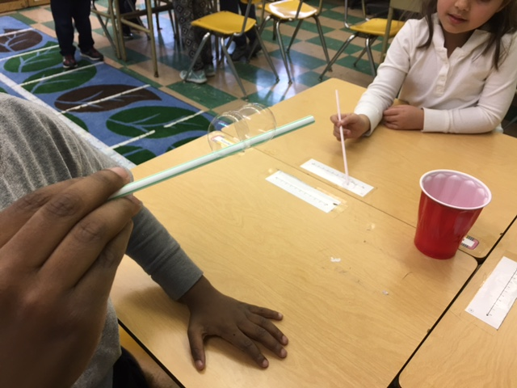

**Announcements**

We will celebrate Valentine’s Day on Feb 14th. If you would like you can prepare their valentines and bring them to school on Monday Feb 13th. We have 13 students and you only need to write your child’s name. And we will place them in each student’s brown bag they decorated for their valentines.

**English**

I can't believe it is February!  We are having a great time in English Language Arts and are continuing to learn so much!

We wrapped up our unit on cultural expressions last week and begin our newest unit with a large focus on science.  We will focus the next few weeks on reading and writing like a scientist.  We will focus our reading on informational texts and compare and contrast those type of texts with fictional stories.  We will also learn to write like scientists with a focus on narrative writing as well as how to write observations and present information to an audience.

Oh - kindergarten parents - be sure to ask your students about super sneaky "E"!

Have a great weekend!

Ms. Wendy

**PYP contents**

* **Science Move**

**- Little Scientist Self Portrait**

**- Properties of Matter**

**- Making Bubble**

**- How do Penguins Stay Dry**

**- Does orange float or sink**

Huang Laoshi