

Panda Class Newsletter



**With Huang Laoshi,**

**Ms. Wendy, and Ms. Lauren**

**Week 25: 2/1/17-2/3/17**



**Weekly News…**

We had a short week due to two Snow Days. This week we focused on our Cultural Exposition preparation. The theme we are celebrating is “shapes”. We learned about different shapes, basic facts about shapes, practiced several shape songs, and created animals by combining shapes. We had a Shapes party on Friday afternoon and they had fun there! They also experienced other three celebration themes hosting by other classes. For math Kindergarten we continued working on number bonds with manipulatives, they practiced what numbers make 5/6/7/8/9/10. For math 1st grade we kept working on shapes and practiced identifying sides and corners. We also reinforced classroom routines and school wide expectations. If you have any questions, please contact us [yuting@gala-prek8.org](mailto:yuting@gala-prek8.org), [wendy@gala-prek8.org](mailto:wendy@gala-prek8.org) or [lauren@gala-prek8.org](mailto:lauren@gala-prek8.org). Thank you so much for your support and have a wonderful weekend!

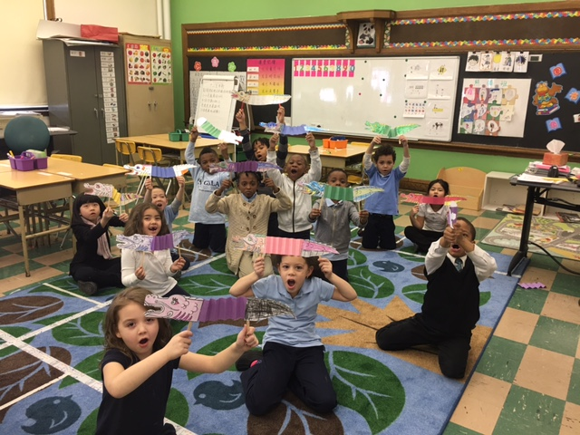

**Announcements**

* We will celebrate Valentine’s Day on Feb 14th. If you would like you can prepare their valentines and bring them to school on Monday Feb 13th. We have 13 students and you only need to write your child’s name. And we will place them in each student’s brown bag for their valentines.
* Panda class weebly site! <http://galapanda.weebly.com/>

**Chinese Learning**

**Q: 这是谁的？**

**A: 我的/不是我的。**

Huang Laoshi

**PYP contents**

* **Cultural Expression: Chinese New Year**

**- 12 Zodiac cartoon**

**- Dragon Puppet**

* **Cultural Expression: Shapes Party**

**- Party invitation card**

**- Shape snacks**

**- Shape games**