

Panda Class Newsletter



**With Huang Laoshi,**

**Ms. Wendy, and Ms. Lauren**

**Week 24: 1/23/17-1/27/17**



**Weekly News…**

The Chinese New Year is coming!!! This week we continued learning about the Chinese New Year. We practiced a song about Chinese 12 Zodiac (十二生肖) and identified their own animals according to the year they was born. We made several fun crafts about the Chinese New Year too! We made little roosters, paper firecrackers with the New Year’s wishes, red envelop, “春” window paper cutting and “福” Chinese brush writing. We also played a game by using chopsticks to pick up gold fish (年年有余).For math Kindergarten we practiced number order to 20 and started number bond with manipulatives. For math 1st grade we kept working on shapes. We also reinforced classroom routines and school wide expectations. If you have any questions, please contact us [yuting@gala-prek8.org](mailto:yuting@gala-prek8.org), [wendy@gala-prek8.org](mailto:wendy@gala-prek8.org) or [lauren@gala-prek8.org](mailto:lauren@gala-prek8.org). Thank you so much for your support and happy Chinese New Year!

Huang Laoshi

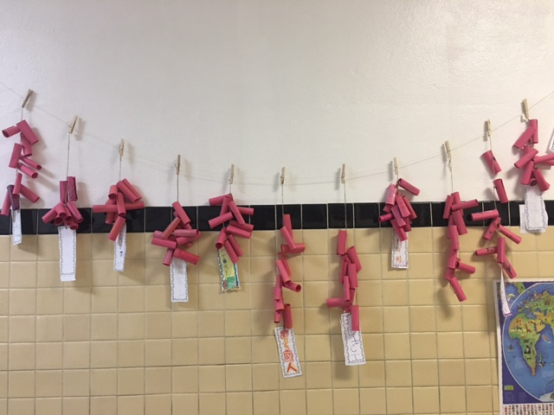

**PYP contents**

* **Cultural Expression: Chinese New Year**

**- 12 Zodiac Song**

**- Year of Rooster craft**

**- Paper Firecracker**

**- “春 ” window Paper Cutting**

**- “福 ” Chinese Brush Writing**

**- Red Envelope**

**Announcements**

* Panda class weebly site! <http://galapanda.weebly.com/>
* Flashcards for the Chinese New Year: <https://quizlet.com/_31f647>
* Flashcards for 12 Zodiac vocabulary: <https://quizlet.com/_30sh3x>

**Chinese Learning**

**十二生肖：鼠、牛、虎、兔、龙、蛇、马、羊、猴、鸡、狗、猪**

**Q:你属什么？**

**A:我属…**