

Panda Class Newsletter



**With Huang Laoshi,**

**Ms. Wendy, and Ms. Lauren**

**Week 23: 1/16/17-1/20/17**



**Weekly News…**

We had a busy but fun week! We start our Chinese New Year celebration this week! We learned about Chinese 12 Zodiac (十二生肖). We learned about the story and names of the 12 animals. This Friday was our 100 Days of School! Thank you for helping them prepare the 100 item project!! They were so excited to show them. During the 100 Days celebration we had so many fun activities! We made 100 glasses, 100 cheerios necklace, stacked 100 paper cups, 100 chart dice race, and chopsticks to pick up pom pom. We also played dice game. For math Kindergarten we started tens and ones. For math 1st grade we started shapes. We also reinforced classroom routines and school wide expectations. If you have any questions, please contact us [yuting@gala-prek8.org](mailto:yuting@gala-prek8.org), [wendy@gala-prek8.org](mailto:wendy@gala-prek8.org) or [lauren@gala-prek8.org](mailto:lauren@gala-prek8.org). Thank you so much for your support and have a good weekend!

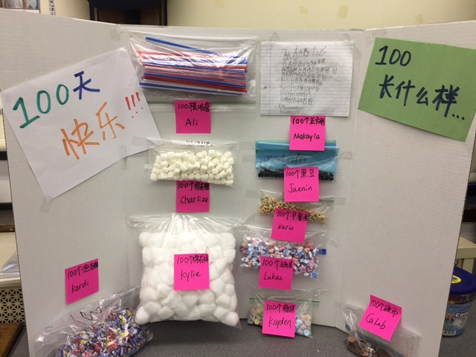

**Announcements**

* If you haven’t signed up for the Student Led Conference (1/24 Tuesday), please sign up for one slot: <http://www.signupgenius.com/go/409084ba4af2ba2f85-student2>
* Panda class weebly site! <http://galapanda.weebly.com/>
* Flashcards for 12 Zodiac vocabulary: <https://quizlet.com/_30sh3x>

**PYP contents**

* **Cultural Expression: Chinese New Year**

**- 12 Zodiac Story**

**Chinese Words**

**马（horse）、牛（cow）羊（sheep）、鸟（bird）**

Huang Laoshi