

Panda Class Newsletter

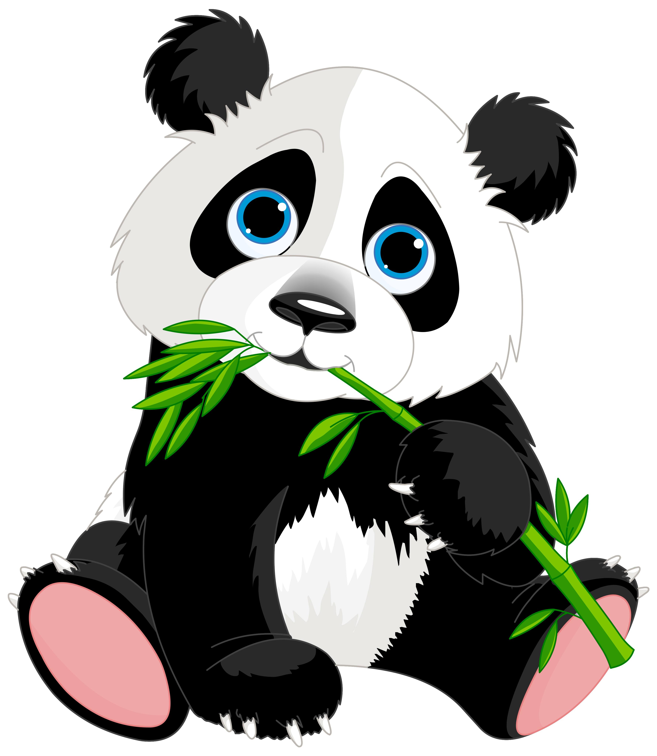

**With Huang Laoshi,**

**Ms. Wendy, and Ms. Lauren**

**Week 22: 1/9/17-1/13/17**



**Weekly News…**

Our learning of different festivals keeps going this week! We learned about Kwanzaa (宽扎节). We learned about the key words in Kwanzaa and made two crafts: Kinara and placemat. We practiced Kwanzaa vocabularies on Quizlet. We learned a new song 动物 (Animal Sounds). Also, they practiced how to say and write their Chinese names all through the week. For math Kindergarten we learned about comparing numbers (多1/少1-one more/one less). For math 1st grade we kept practicing subtraction within 20 by different ways. We also reinforced classroom routines and school wide expectations. If you have any questions, please contact us [yuting@gala-prek8.org](mailto:yuting@gala-prek8.org), [wendy@gala-prek8.org](mailto:wendy@gala-prek8.org) or [lauren@gala-prek8.org](mailto:lauren@gala-prek8.org). Thank you so much for your support and have a good weekend!

**Announcements**

* No school next Monday (1/16) – MLK Day
* Please sign up for the Student Led Conference (*Jan 19 or Jan 24*), links are attached in email
* Students will have NWEA Map test next week
* Panda class weebly site! <http://galapanda.weebly.com/>
* Flashcards for Kwanzaa vocabulary: <https://quizlet.com/_2ykve1>

**Art**

This week the students completed the paper mâché step of their mask making project. These masks will be used during their classroom celebration that they are designing themselves. This week we focused on a different process which used diluted wood glue instead of flour and water as an adhesive to provide additional strength to the sculptures. Next week we will be painting and decorating the masks. You can ask your student about their classroom celebration and how they plan to decorate their masks. It's important to help them realize that their masks are sculptures and they are considered part of a costume.

**Kwanzaa Words Learning**

**宽扎节(Kwanzaa) 垫子(Placemat) 玉米 (Corn)**

**七支蜡烛(Seven Candles) 蜡烛台(Kinara)**

**农作物(Crops) 团结杯(Unity Cup) 礼物(gift)**

**非洲人(Africans) 斯瓦希里语 (Swahili)**

**PYP contents**

* **Cultural Expression: Kwanzaa**

**- Kinara**

**- Placemat**

Huang Laoshi