

Panda Class Newsletter



**With Huang Laoshi,**

**Ms. Wendy, and Ms. Lauren**

**Week 21: 1/4/17-1/6/17**



**Weekly News…**

Welcome back to school! We reviewed how people celebrate Hanukkah and Christmas. We also start to introduce about Kwanzaa (宽扎节) and how people celebrate this holiday. We talked about how they light up the candles, the colors, the sequence and the 7 principles. We made a hat and dance with the Kwanzaa music. The most exciting news is everyone received their Chinese names this week. We practiced how to say and write their names. For math Kindergarten we finished more or less (多/少). For math 1st grade we finished single digit addends addition and learned about one addend is more than 10 addition. We also reinforced classroom routines and school wide expectations. If you have any questions, please contact us [yuting@gala-prek8.org](mailto:yuting@gala-prek8.org), [wendy@gala-prek8.org](mailto:wendy@gala-prek8.org) or [lauren@gala-prek8.org](mailto:lauren@gala-prek8.org). Thank you all for support and have a wonderful weekend and Happy New Year!

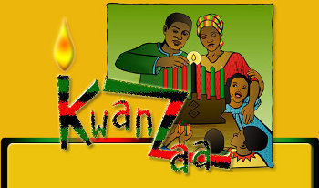 

**Announcements**

* Panda Class Chinese Names: <https://quizlet.com/_2yl8au>
* Kwanzaa Vocabulary:

<https://quizlet.com/_2ykve1>

* Panda class weebly site: <http://galapanda.weebly.com/>
* Please check out their green folders every day for communications and homework.

**Chinese Sentence**

**A: 你叫什么名字？What is your name?**

**B: 我叫…。I’m…**

Huang Laoshi

**PYP contents**

* **Cultural Expression: Kwanzaa Celebration**

**- 7 candles and 7 principles**

**- Music and Dance**

**- Hat and colors**