

Panda Class Newsletter

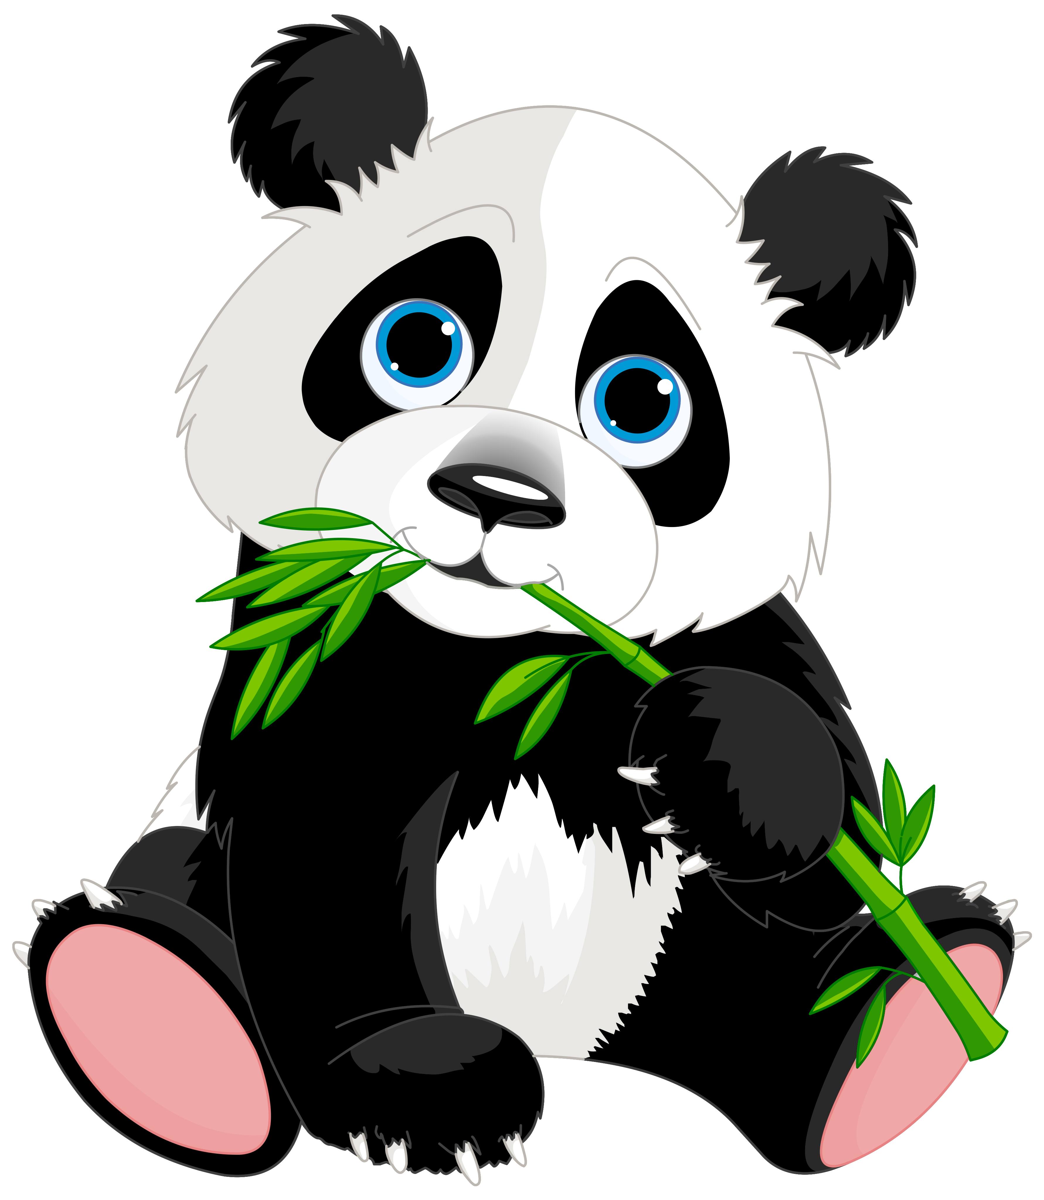

**With Huang Laoshi,**

**Ms. Wendy, and Ms. Lauren**

**Week 17: 11/28/16-12/2/16**



**Weekly News…**

Happy Week 17! It’s our second week of Unit 3 Cultural Expressions. We continued learning about the holiday “Thanksgiving” (感恩节). We compared the first Thanksgiving and Thanksgiving nowadays. We discussed about how we can express our thanks. We decorated a “Thank You Tree” for the people we want to say “Thank You”. We asked them to take it home and say “谢谢” to their family. Plus we made a “五月花号” Mayflower boat align with the story about how we have Thanksgiving Holiday. For math Kindergarten we learned about length (长/短) and height (高/矮). For math 1st grade we learned and practiced ordinal numbers (第一,第二,第三,第四…) and started numbers to 20. We also reinforced classroom routines and school wide expectations. If you have any questions, please contact us [yuting@gala-prek8.org](mailto:yuting@gala-prek8.org), [wendy@gala-prek8.org](mailto:wendy@gala-prek8.org) or [lauren@gala-prek8.org](mailto:lauren@gala-prek8.org). Thank you so much and enjoy the long break!

**Announcement**

* No school on next Monday Dec 5th-PD
* We will be working on our new Unit-Cultural Expression in the following 6 weeks. If you would like to present your culture (stories/food/song/dance/play…) during our unit learning please let us know. We would love to have parents/volunteers come and share their culture.
* Panda class weebly site: <http://galapanda.weebly.com/>
* Thanksgiving flashcards: [https://quizlet.com/_2ulznc](%20https:/quizlet.com/_2ulznc)

**Art**

This week our students completed their cast paper low relief sculptures of healthy fruits and vegetables. They turned out great and the students are really proud of their work. The last step was to paint. Students learned how to mix primary colors (red, yellow and blue) to make secondary colors (green, orange and purple). Also, we began our unit on cultural celebrations. In art each class will be developing their own celebration for something they feel is important to celebrate. We will design costumes, create decorations, select a color scheme and develop symbols for each celebration over the next few weeks.

**Chinese Writing**

**山（mountain）人（people）水 （water） 火（fire）**

**PYP contents**

* **Cultural Expression: Thanksgiving**

**- Compare the first Thanksgiving and Thanksgiving nowadays**

**- Thank You Tree (Sentence Structure: 我谢谢…)**

**- Mayflower Craft 五月花号**

Huang Laoshi