

Panda Class Newsletter



**With Huang Laoshi,**

**Ms. Wendy, and Ms. Lauren**

**Week 16: 11/21/16-11/22/16**



**Weekly News…**

Welcome to our holiday week! We started the new unit “Cultural Expressions” this week and it perfectly fits in our holiday week! We learned about Thanksgiving by watching the history cartoon, sharing personal experience and making crafts. We made a placemat and a turkey hat for Thanksgiving. In Chinese characters writing, we reviewed “坐”、“不”、“在”、“里”. We practiced the morning exercise every day and everyone loved it! We also reinforced classroom routines and school wide expectations. If you have any questions, please contact us [yuting@gala-prek8.org](mailto:yuting@gala-prek8.org), [wendy@gala-prek8.org](mailto:wendy@gala-prek8.org) or [lauren@gala-prek8.org](mailto:lauren@gala-prek8.org). Thank you so much and have a warm holiday!

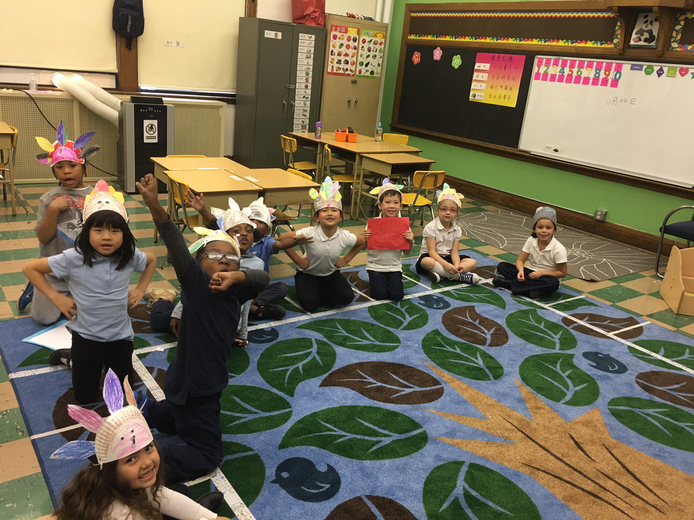

**Announcement**

* We have no school on the follow date:

-November 23-25  Thanksgiving

* We will be working on our new Unit-Cultural Expression in the following 6 weeks. If you would like to present your culture (stories/food/song/dance/play…) during our unit learning please let us know. We would love to have parents/volunteers come and share their culture.
* Panda class weebly site: <http://galapanda.weebly.com/>

Huang Laoshi

**Chinese Writing**

**在（at） 里（inside）**

**不 （no） 坐（sit）**

**PYP contents**

* **Cultural Expression: Thanksgiving**

**- The placemat**

**- The turkey hat (see picture below)**