

Panda Class Newsletter



**With Huang Laoshi,**

**Ms. Wendy, and Ms. Lauren**

**Week 15: 11/14/16-11/18/16**



**Weekly News…**

Welcome to Week 15! This is the last week of our “Healthy Living” unit. We have learned 运动 (movements) including different sports and movement words. We practiced 做早操 (Morning exercise, see picture below) with all movement words we learned in Chinese. We also talked about what a healthy day look like to them. We made a book about “健康的一天” (a healthy day). For math, we practiced pattern for kindergarteners and subtraction within 10 for 1st graders. We also reinforced classroom routines and school wide expectations. If you have any questions, please contact us [yuting@gala-prek8.org](mailto:yuting@gala-prek8.org), [wendy@gala-prek8.org](mailto:wendy@gala-prek8.org) or [lauren@gala-prek8.org](mailto:lauren@gala-prek8.org). Thank you all for support and have a great weekend!

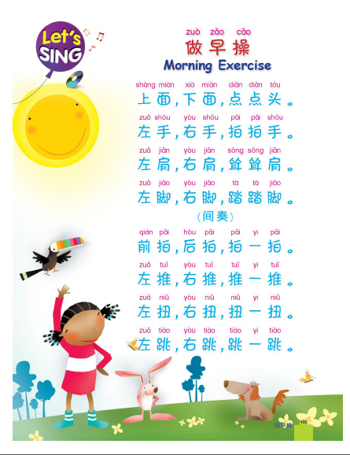

Huang Laoshi

**Announcement**

* We have no school on the follow date:

-November 23-25  Thanksgiving

* No aftercare/afterschool enrichment on November 22.
* We will start our new Unit-Cultural Expression next week. If you would like to present your culture (stories/food/song/dance/play…) during our unit learning please let us know. We would love to have parents/volunteers come and share their culture.
* Movements flashcards are on Quizlet: <https://quizlet.com/_2swiwr>
* Panda class weebly site: <http://galapanda.weebly.com/>

**Chinese Writing**

**在（at） 里（inside）**

**不 （no） 坐（sit）**

**PYP contents**

* **Healthy living**

**- Morning Exercise 做早操**

**- My healthy day book 健康的一天**