

Panda Class Newsletter



**With Huang Laoshi,**

**Ms. Wendy, and Ms. Lauren**

**Week 11: 10/17/16-10/21/16**



**Weekly News…**

This week we still work on our healthy fruits. We made several fruit crafts and learned a fruit song 水果歌. We started our learning centers this week with four different interest groups: Playdoh group, Writing group, Puzzle group and Reading group. For math, we finished number order (Kindergarten) and addition<10 (1st grade). We also reinforced classroom routines and school wide expectations. If you have any questions, please contact us [yuting@gala-prek8.org](mailto:yuting@gala-prek8.org), [wendy@gala-prek8.org](mailto:wendy@gala-prek8.org) or [lauren@gala-prek8.org](mailto:lauren@gala-prek8.org). Thank you all for support and have a good weekend!

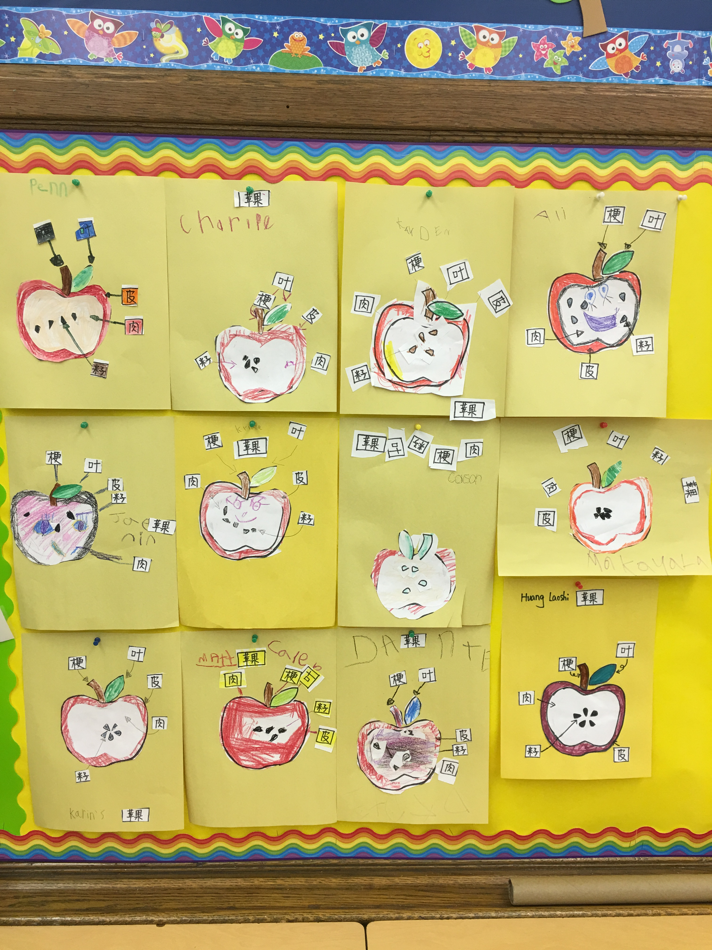

Huang Laoshi

**We know about apples!**

**Announcement**

* **Thank you all for attending our first teacher-parent conference!!!**
* **Songs, pictures and other resources are available at our class blog:** [**http://galapanda.weebly.com/**](http://galapanda.weebly.com/)
* **School Picture Day will be on next Thursday (October 27, 2016), please make sure return the Picture Day order form**
* **It’s getting cold. Please make sure you prepare a name-labeled jacket/coat for your child.**

**PYP contents**

* **Healthy Living**

**-Fruit crafts**

1. **Pineapple**
2. **Grape**
3. **Apple**

**Chinese Words Writing**

**日(sun, day)**

**月(moon, month)**