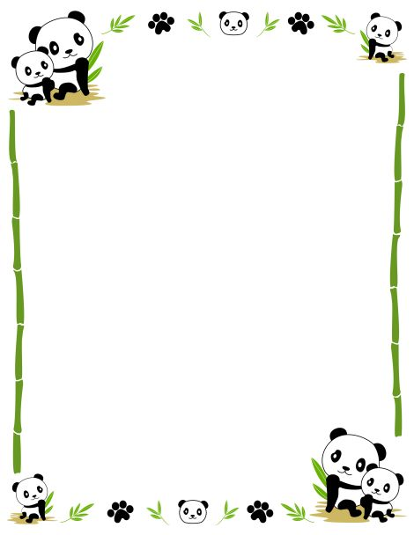

Welcome to Mandarin K/1 Immersion Class
-The Panda Class 熊猫班
Dear families,

Welcome to the Panda Class (熊猫班) at GALA! We are very excited to start a new school year filled with fun, laughter, learning and love. We name our class the Panda Class because when people think of China, they often think of the panda. The Chinese regard them as a symbol for friendship and peace. We want to develop a friendly and peaceful environment for your child to play and learn.

- Mandarin Teacher
My name is Yuting Huang (我的名字叫黄宇亭). My hometown is called Fuzhou, a southeast city in China. I had my Bachelor’s Degree in English and then came to the U.S. in 2012 to pursue my master's degree in St. Louis, Missouri. I received my Master’s Degrees in Secondary Education (2014) and Elementary Education (2016) from University of Missouri-St Louis. Meanwhile, I worked in a local language immersion school for 3 years. Based on my experience, I do believe that multilingualism offers immediate cognitive advantages to kids and help their brains work more efficiently, and kindergarten is absolutely a good time to start the journey.

- English Teacher
My name is Kara Kirby. I have a Masters degree in curriculum and instruction and I am currently completing my doctorate in Comparative and International Education. I grew up on the east side of Cleveland, and moved to Tanzania after graduating from college. I lived in Tanzania for 16 years where I co-founded a center for street children and worked as a 2nd & 3rd grade teacher at an International Baccalaureate (IB) World international school for 10 years. I am very experienced in designing and implementing the IB Primary Years Programme (PYP). I will develop phonemic awareness through read-aloud, guided reading/writing, and instructional reading/writing. Students will explore texts through daily independent reading. Reading and writing will be connected to our unit of inquiry. At times during the week I will reinforce numeracy concepts being taught in the Mandarin classroom. As co-teachers we work very closely to ensure your child’s curriculum is aligned through both classrooms.

In order for us to make this year as successful as possible, we will be doing our best to create an environment in the Mandarin classroom where all communication is done only in Mandarin. It will be essential that your child believe that Huang Laoshi (黄老师) only speaks Mandarin. When you need to speak to her right away she will step out and speak with you in private. We highly encourage you to email us or leave a note in the office and we will reply as soon as possible. We know this is going to be a great year, and we really appreciate your support with this. Please feel free to contact us if you have any concerns. Be assured that at any time when your child’s safety is concerned, we will not hesitate to communicate with him/her in English.

Thank you very much! We are excited to work with you this year!

Sincerely,
Huang Laoshi and Ms. Kara
yuting@gala-prek8.org kara@gala-prek8.org
Global Ambassadors Language Academy
216-315-7942

